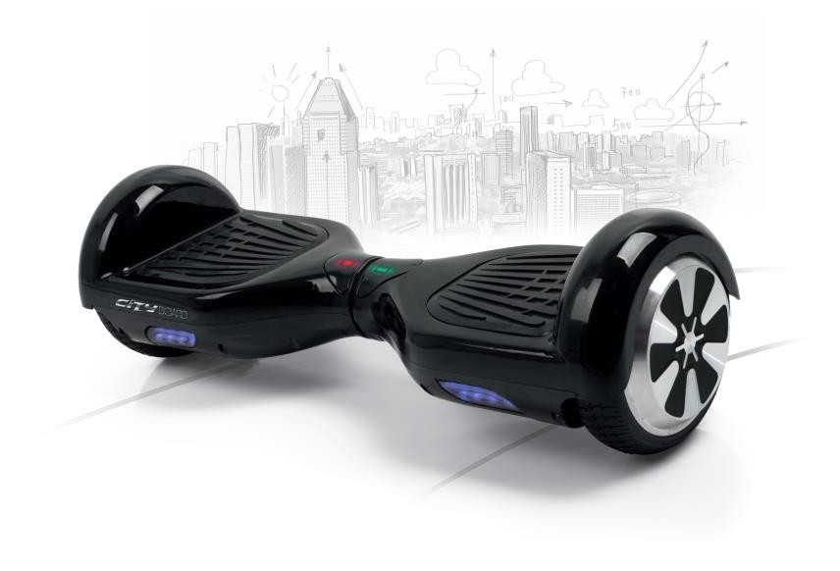

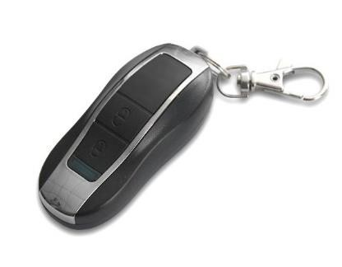

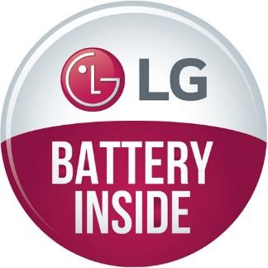
LOGISTIC DATA
Dimensions of unit box: 65,5 x 25 x 25 cm Dimensions of collective box: 65,5 x 25 x 25 cm Weight of collective box: 11,5 kg
Number of pieces in collective box: 1 Quantity of collective boxes on pallet:16 pcs

Selling points:
- Stable, fast
- Innovative transportation technique
- Up to 20 Km distance
- Built-in Bluetooth Speaker
- LG battery
- Included bag to easy carrying and protect
- Included remote for easy locking and unlocking

Specification:

Gyroscope: | 2-axis
Travel distance: | Up to 20 Km
Max. power: | 700 W (2x350W)
Max. speed: | 15 km/h
Battery: | LG battery  36V x 4,4Ah Li-Ion
Charging time: | 240 minutes
Color variants: | Black, White
Wheels diameter: | 6.5” / 17 cm
Working temperature: | 10°C - 40°C
Max. load: | 100 kg
Max. climbing angle: | 15°
Accessories: | Battery charger (certified by GS), protective bag, remote, built-in Bluetooth Speaker
Other: | Audio warning when maximum leaning point is reached.  Audio warning when battery is discharged Locking and unlocking board with remote, led lights.

PRODUCER/PRO
,

PRODUCT EAN: 5906736072371 (black), 5906736072388 (white)
PRODUCT

